
SRM Institute of Science and Technology
SET B
College of Engineering and Technology
School of Computing
SRM Nagar, Kattankulathur – 603203, Chengalpattu District, Tamilnadu
Academic Year: 2022-23 (EVEN)
Test: CLA-T1 Date: 10.02.2023
Course Code & Title: 18CSC205J - Operating Systems Duration: 50 Minutes
Year & Sem: II Year / IV Sem Max. Marks: 25

Course Articulation Matrix: (to be placed)
S.No | Course Outcome | PO1 | PO2 | PO3 | PO4 | PO5 | PO6 | PO7 | PO8 | PO9 | PO10 | PO11 | PO12 | PSO1 | PSO2 | PSO3
1 | CO1 | 3 |  | 3 |  |  |  |  |  |  |  |  |  | 2
2 | CO2 | 2 | 1 | 3 |  |  |  |  |  |  |  |  |  |  | 2
3 | CO3 | 3 | 2 | 2 |  |  |  |  |  |  |  |  |  | 2
4 | CO4 | 3 | 2 | 2 |  |  |  |  |  |  |  |  |  |  | 2
5 | CO5 | 3 |  | 2 | 2 |  |  |  |  |  |  |  |  | 2

Part - A
(10 x 1 = 10 Marks)
Instructions: Answer all
Q. No | Question | Mark | BL | CO | PO | PI Code
 | Assume that P1 and P2 are two processes. P2 is a child of P1. P2 completed the task, but P1 keeps executing then P2 is called  - Orphan  - New  - Zombie  - Dead  Ans: C Zombie | 1 | 2 | 1 | 1 | 1.6.1
 | ._______________ selects processes which should be brought into the ready queue and controls the degree of multiprogramming  - Short time scheduler  - Medium time scheduler  - Long time scheduler  - I/O scheduler  Answer C | 1 | 1 | 1 | 1 | 1.6.1
 | State whether true or false.  1. Multi-threading is useful for application that perform a number of essentially independent tasks that do not be serialized.  2. An example of multi-threading is a database server that listens for and process numerous client request.  - i-True, ii-False  - i-True, ii-True  - i-False, ii-True  - i-False, ii-False  Answer : B | 1 | 3 | 1 | 3 | 3.7.1
 | The ________ system call is used by the parent to combine the termination of child process  - wait  - exit  - fork  - Join  Ans: A | 1 | 1 | 1 | 1 | 1.6.1
 | …………… refers to the ability of multiple process (or threads) to share code, resources or data in such a way that only one process has access to shared object at a time.  A) Synchronization  B) Mutual Exclusion  C) Dead lock  D) Starvation  Answer : B | 1 | 2 | 1 | 1 | 1.7.1
PART B – 10 Marks
Answer any Two Questions
 | What is the importance of interprocess communication when processes are executing concurrently in the operating system? Explain with example  Ans:  IPC Definition: 2 marks  Interprocess communication (IPC) is a process that allows different processes of a computer system to share information. IPC lets different programs run in parallel, share data, and communicate with each other.  Importance of IPC: 4 marks  - t speeds up the execution of tasks.  - It ensures that the tasks run correctly and in the order that they were executed.  - IPC is essential for the efficient operation of an operating system.  - Operating systems use IPC to exchange data with tools and components that the system uses to interact with the user, such as the keyboard, the mouse, and the graphical user interface (GUI).  - IPC also lets the system run multiple programs at the same time.  Example: 4 marks ( Any suitable example can be considered)  When you are using a team-based system, it is necessary to communicate with all the teams in the company. Some of them are the Business Objects team, the product sales team, and others are the technical teams. Communication between them will speed up the work and overall efficiency will also increase. So, in the same way, an operating system allows a particular program to handle several user requests simultaneously. And overall efficiency will increase. | 10 | 3 | 1 | 3 | 3.6.2
 | Discuss the essential properties of the following types of systems.  - Time sharing systems.  Key: It allows the user to perform more than one task at a time, each task getting the same amount of time to execute. Hence, the name time sharing OS. Moreover, it is an extension of multiprogramming systems. In multiprogramming systems, the aim is to make the maximum use of the CPU. On the other hand, here the aim is to achieve the minimum response time of CPU. (3 marks)  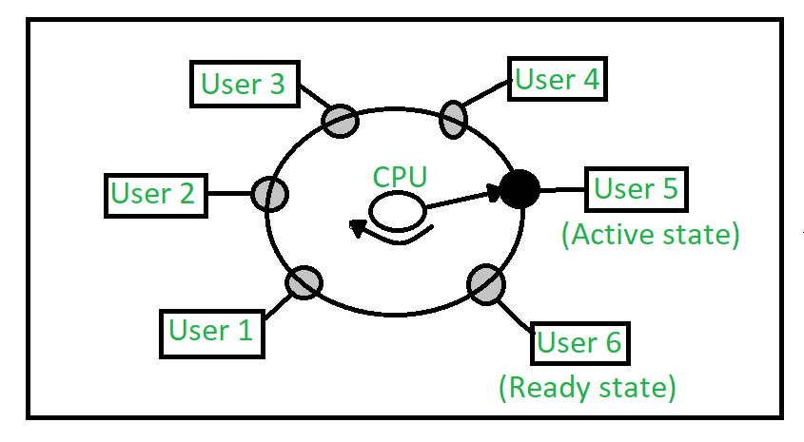  Diagram and its Explanation ( 2 marks)  - Multi-programmed batch systems.  On a single processor computer, a multiprogramming OS can run many programs. In a multiprogramming OS, if one program must wait for an input/output transfer, the other programmes are ready to use the CPU. As a result, different jobs may have to split CPU time. However, their jobs are not scheduled to be completed at the same time.  When software is run, it is referred to as a “Task,” “Process,” or “Job.” When compared to serial or batch processing systems, concurrent program executions reduce system resource usage and increase throughput.  Multiprogramming’s main purpose is to manage all of the system’s resources. The file system, transient area, command processor, and I/O control system are the main components of a multiprogramming system. As a result, the multiprogramming OS is built to store many programs based on sub-segmenting the transient area. The operating system’s essential functions are tied to the resource management processes.  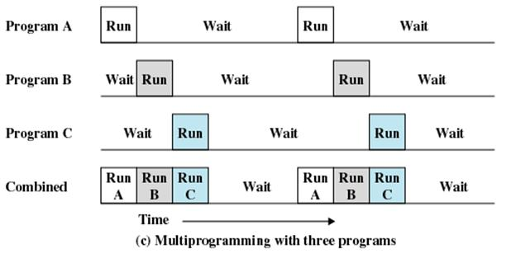 | 10 | 2 | 1 | 1 | 1.7.1
 | Describe the differences among short- term, medium-term and long term scheduling with suitable example.  Schedulers  Schedulers are special system software which handle process scheduling in various ways. Their main task is to select the jobs to be submitted into the system and to decide which process to run. | 10 | 1 | 1 | 3 | 3.6.2
  S.No | Long-term Scheduler | Short-term Scheduler | Medium -term Scheduler
  1 | It is job Scheduler | It is CPU scheduler | It is process swapping scheduler
  2 | speed is lesser than short term scheduler | Speed is fastest than other two schedulers and invoked frequently | speed is between both short and long term scheduler
  3 | It controls degree of multiprogramming | It provide lesser control over degree of multiprogramming | It reduces the degree of multiprogramming
  4 | It is almost absent or minimal in time sharing system | It is almost minimal in time sharing system | It is part of time sharing system
  5 | It selects process from pool and loads them into memory for execution | It selects those processes which are ready to execute | It can reintroduce the process into memory and execution cannot e continued
  6 | Transition of process state from new to ready state | Transition of process state from ready to executing state | No process state transition
  7 | Supplies a mix of jobs, such as I/O bound and CPU bound | Selects a new process to allocate CPU frequently | Process are swapped in and out for balanced process mix

